// Adrian Pailler//

package Lesson7;

import java.util.*;

import javax.swing.*;

public class Searching_alg {

// array that will be created and used by all sorts/searches //

static ArrayList<String> arr = new ArrayList<String>() ;

// main method which will perform user required search/sort //

public static void main(String[] args) {

input(); // see input method (42-53) //

int ans = choice(); // decides which method to call. see choice method (29-40) //

if(ans==0) {

linear(); // see linear method (60-72) //

}

else if(ans==1) {

binary(); // see binary method (88-109) //

}

else if(ans==2){

bubble(); // see bubble method (74-86) //

}

else if(ans == 3){

selection(); // see selection method (111-125) //

}

else {

JOptionPane.showMessageDialog(null, "Bye!");

}

}

// 9/01/21 ; user decision //

public static int choice() {

JFrame choice = new JFrame();

String[] options = new String[4];

options[0] = new String("linear search");

options[1] = new String("binary search");

options[2] = new String("bubble sort");

options[3] = new String("selection sort");

// creates four options//

int ans =JOptionPane.showOptionDialog(choice.getContentPane(),"What would you like to do with your array?","Sorting and Searching",0,JOptionPane.INFORMATION_MESSAGE,null,options,null);

return ans;

// returns the value of ans to be used in the main method//

}

// 9/01/21 ; user input array //

public static ArrayList<String> input() {

// array that will be created and used by all sorts/searches //

String temp;

// Temporary value to add new elements //

int length = Integer.parseInt(JOptionPane.showInputDialog(null,"How long do you want your array?"));

// allows user to give predefined length //

for(int count = 0;length>count; count++) {

temp = JOptionPane.showInputDialog(null,"Input your array: ");

arr.add(temp);

}

return arr;

}

// 9//01//21 ; requests the search element //

public static String search() {

String element = JOptionPane.showInputDialog(null, "Which element are you looking for?");

return element;

}

// 9/01/21 ; Linear search //

public static void linear() {

String element = search(); // see search method (55-58) //

boolean flag = false;

for(int i = 0; i<arr.size();i++) {

if(arr.get(i).compareTo(element)==0) { // compares ascii values //

JOptionPane.showMessageDialog(null,"The index of your searched value is: "+arr.indexOf(element)); // if true, element found //

flag = true; // breaks loop//

}

}

if(flag == false) {

JOptionPane.showMessageDialog(null, "This value is not an element of the array");

}

}

// 10/01/21 ; bubble sort //

public static void bubble() {

String temp; // temporary value needed to change positions //

for(int i = 0;i<arr.size();i++) { // outer loop//

for(int a = 0; a<arr.size()-i-1;a++) { // inner loop //

if(arr.get(a).compareTo(arr.get(a+1))>0) { // compares both elements lexicographically //

temp = arr.get(a); //

arr.set(a,arr.get(a+1)); // swaps position

arr.set(a+1,temp); //

}

}

}

JOptionPane.showMessageDialog(null, "The sorted array is: "+arr);

}

// 11/01/21 ; binary search //

public static void binary() {

String element = search(); // see search method (55-58) //

bubble(); // array needs to be sorted first //

boolean flag = false;

int min = 0;

int max = arr.size()-1;

while(max>=min) {

int mid = (min+max)/2; // gets the midpoint

if((arr.get(mid).compareTo(element))<0) { // compares ascii //

min = mid+1;

} else if((arr.get(mid).compareTo(element))>0) {

max = mid-1;

} else {

JOptionPane.showMessageDialog(null, "Element found at index: "+mid);

min = arr.size()+1; // breaks while condition//

flag = true;

}

}

if(flag==false) { //if value is not an element //

JOptionPane.showMessageDialog(null, "This value is not an element of the array");

}

}

// 11/01/21 ; selection sort//

public static void selection() {

String temp;

int i,e; // will be counters to compare elements //

for(i=0;i<arr.size();i++) { // outer loop//

for(e=i+1; e<arr.size();e++) { // nested loop //

if(arr.get(i).compareTo(arr.get(e))>0) { // conditions to compare ascii //

temp = arr.get(i); //

arr.set(i, arr.get(e)); // swap values if condition is met

arr.set(e, temp); //

}

}

}

JOptionPane.showMessageDialog(null, "The sorted array is: "+arr);

}

}

Linear search:

Array: {g,4,6,c,e}

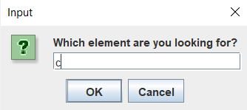Search term:

Binary search:

Array: {g,4,6,c,e}

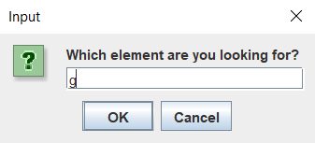Search term:

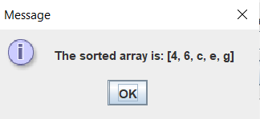Sorted array:

Bubble sort:

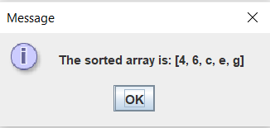Array: {g,4,6,c,e}

Sequential sort:

Array: {g,4,6,c,e}

Array: {f,3,3,5,g,s,e,w,m,n}

